Samuel Bernheim (bernheim@brandeis.edu) 2016-3-9

Problem 3.12

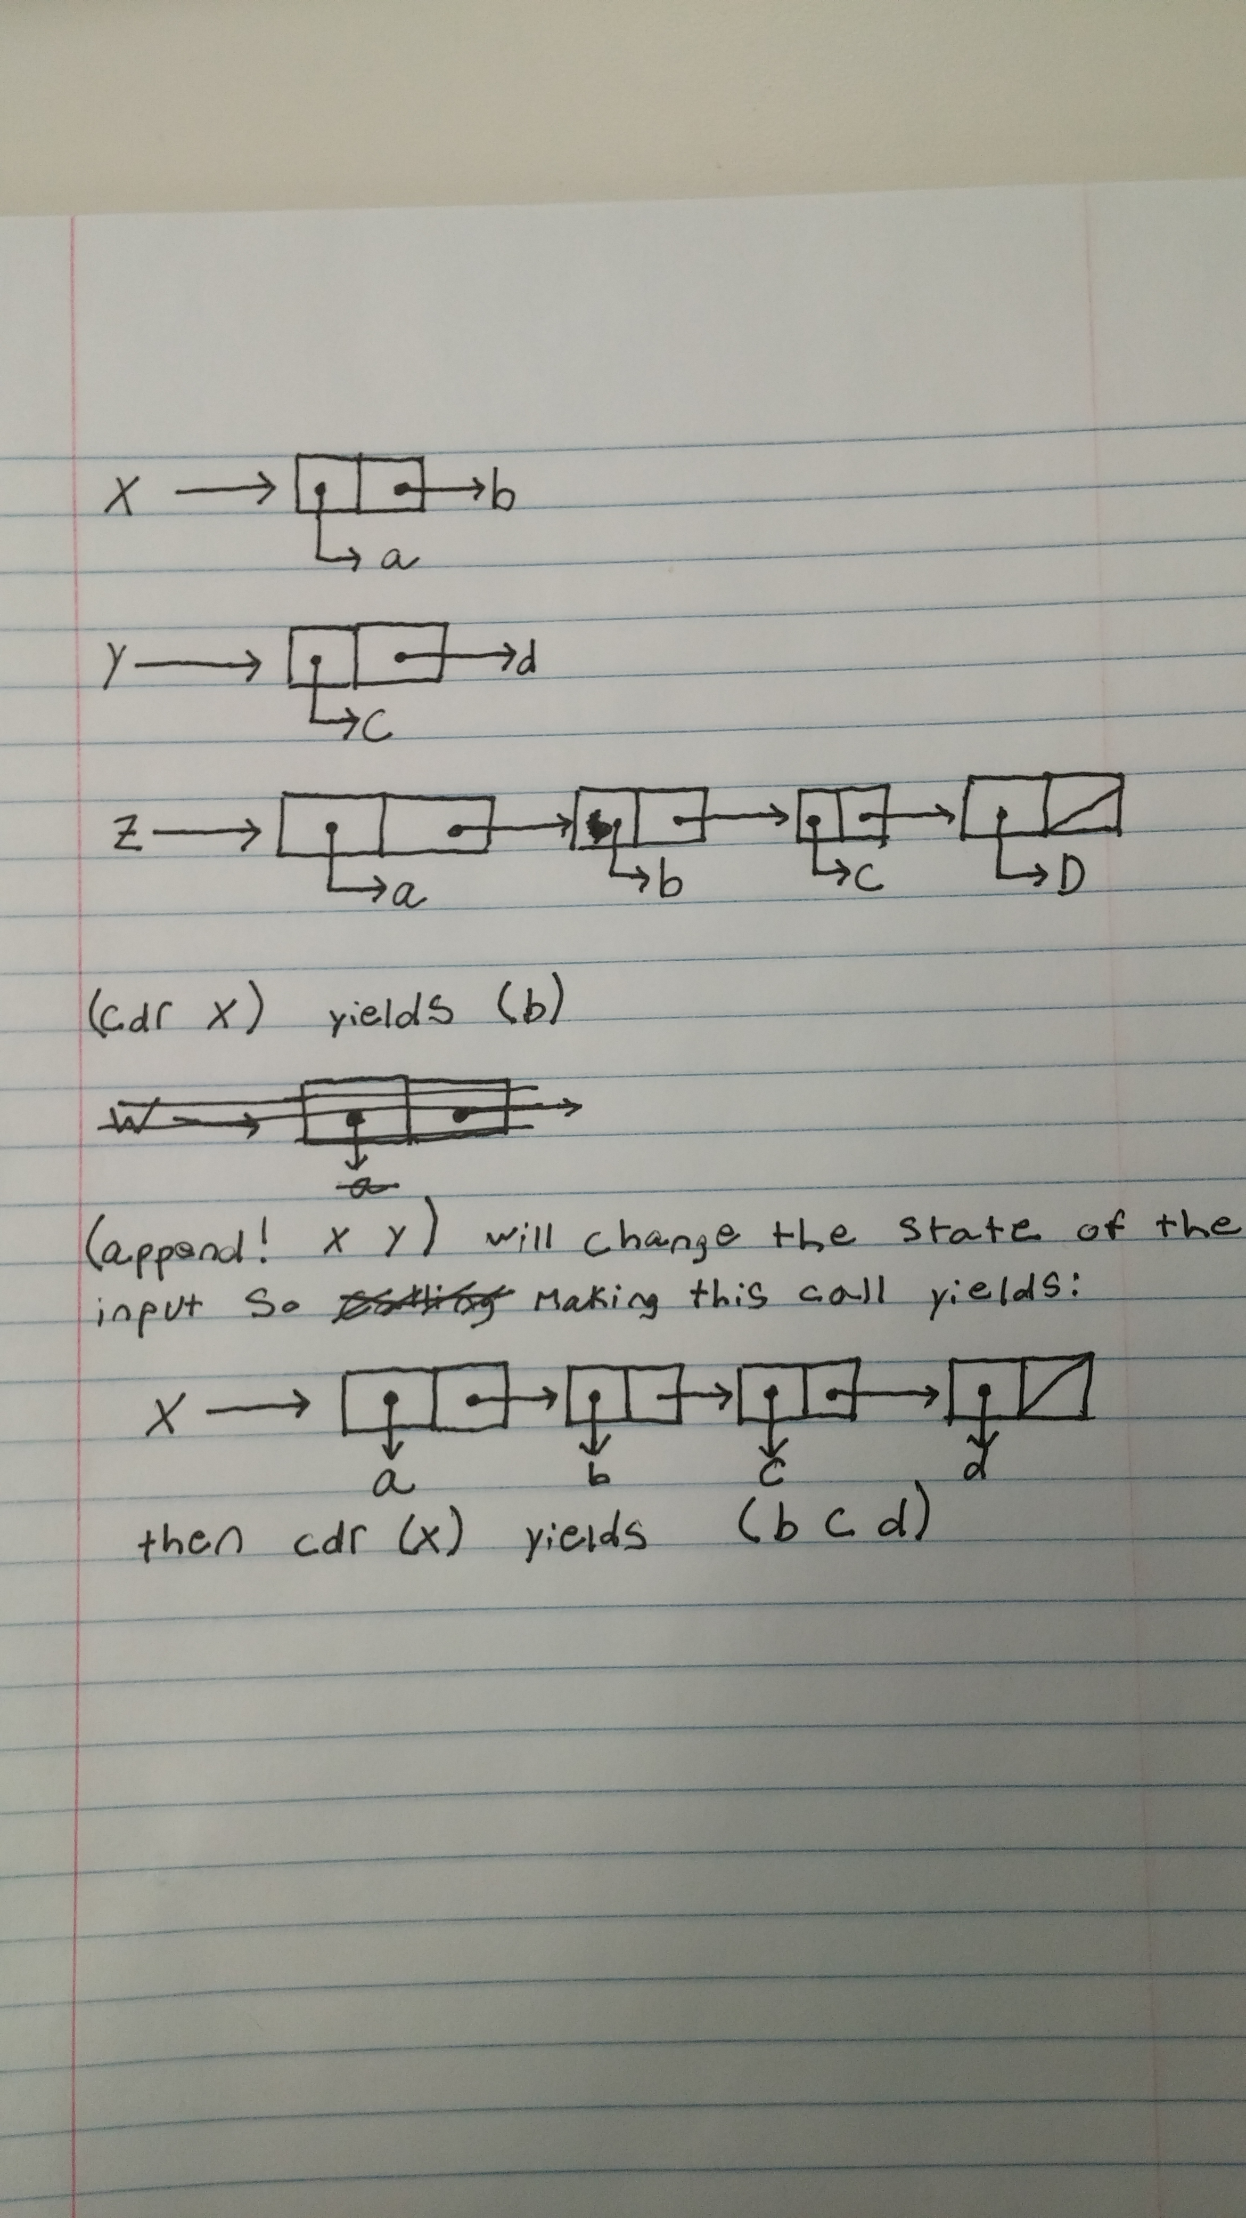

Problem 3.14

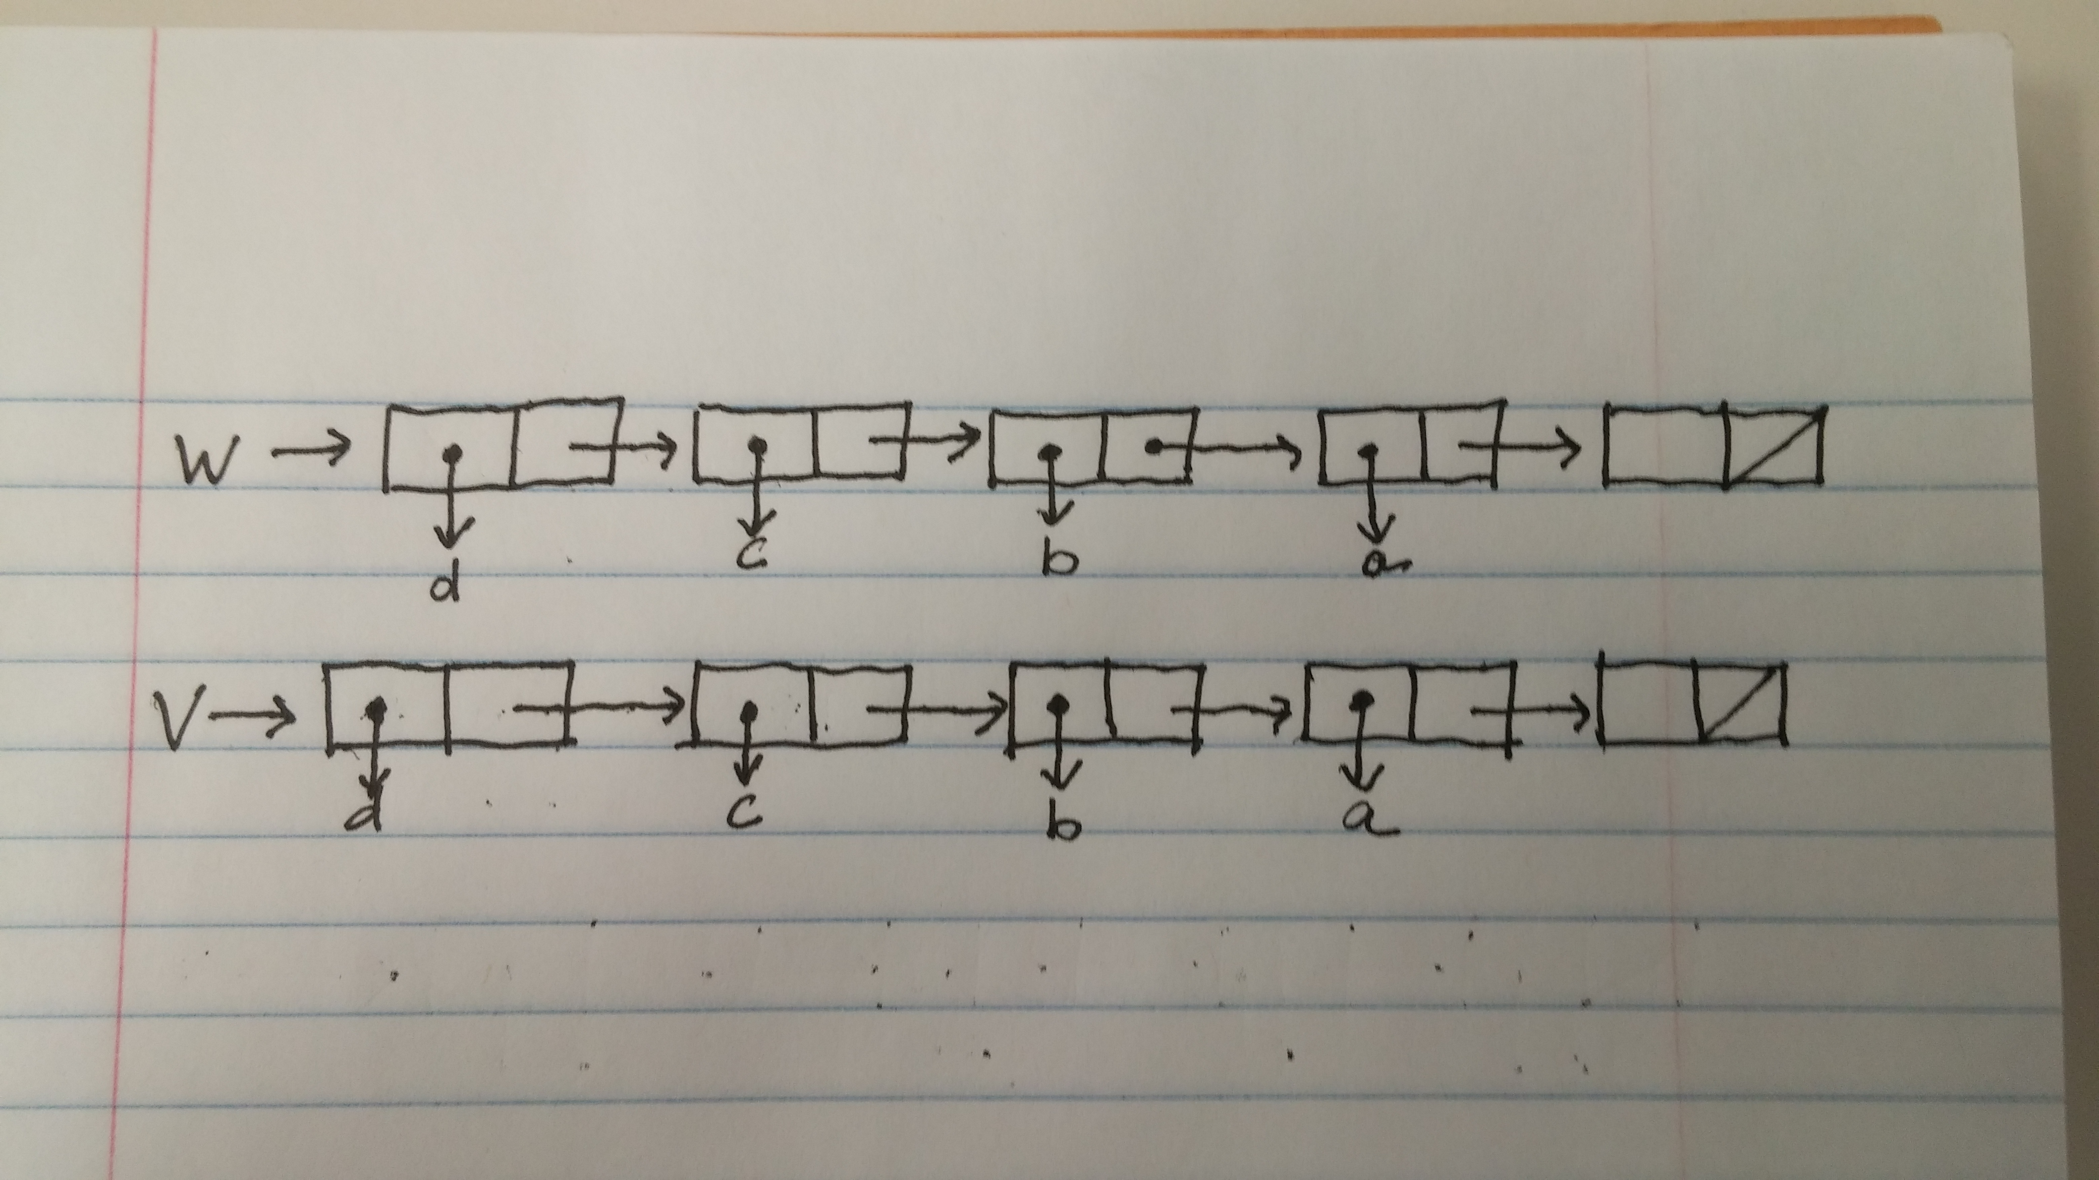

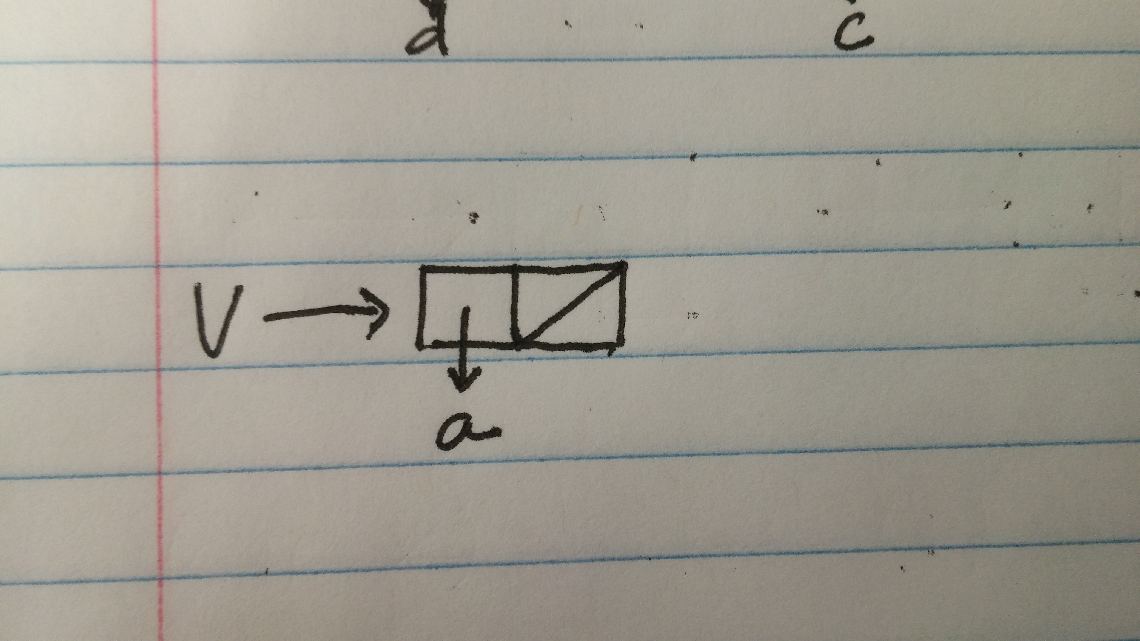

Printing v would result in (a). Printing w would result in (d c b a).

Problem 3.17

For this problem I first wrote a contains? procedure which given a list and an element will determine if the element is in the list. Then I defined another function called good-count which takes in for parameters two lists and a counter. One of the two list is the list being counted and the other is a list of elements which have already been seen. I go through the lst checking if its null in which case counter is returned, and if the first element in lst has been seen before. If it hasn’t the first element is added to the already-seen lst and the recursive call is made. If it has then the recursive call is made without modifying the already-seen list.

When I run it though I keep getting an mcar: contract violation error and couldn’t figure out where this was coming from.

Stable Marriage

Question 1

For the couple? procedure I got the two people person1 and person2 are engaged to and checked if person1 was the same as the person, person2’s partner and if person2 was the same as person1’s partner.

For the currently-unengaged? procedure I used a lambda expression which takes an additional list as a parameter and then check to see if the first person in the list-of-people was engaged or not. Based on this I would make the appropriate recursive call.

For the send? procedure I first would check if the list-of-people was empty. If so then true is returned. Otherwise message is called on the first thing in the list and then send is called on the cdr of the list.

For the i-like-more? procedure I began by first getting the corresponding index of where each of the two people are for the person. Then I figure out which one is smaller and return the corresponding person.

Question 2

To complete the i-love-you procedure I handled the three possible cases. If the person being proposed to is unengaged, then that person accepts and the proposee’s current intended is set to the proposer and the phrase i-love-you-too is returned. Otherwise the propose is engaged. In this case I first determine if the propose likes the proposer more than they like the person to whom they are currently engaged. If they do, then the phrase buzz-off-you-creep is returned. Otherwise i-changed-my-mind is called on the proposee’s current-intended, the proposee’s current intended is changed to be the proposer, and i-love-you-too is returned.

Question 3

Question 4

Proof by contradiction. Assume there was some person who was not engaged. This means one of two things. Either this person, person A, was never proposed to, or at some point was engaged but then changed their mind and never got reengaged. Assume also there are the same number of men and women. In the first case since every man proposes to every woman and there are the same number of men and woman, everyone man is at some point engaged. Since once a man is engaged he is never unengaged, and every man proposes to every woman if there is some woman not engaged it is because she has just not yet been proposed to but every woman is proposed to at some point 🡪 Contradiction. In the second case, if some woman W was engaged at one point but then got unengaged, there must exist some man M who has not yet proposed to W in which case W will eventually get engaged to M since at this point W is unengaged and will thus accept any proposal.

Question 5

The algorithm works by having P propose in a descending order of preference. Additionally, P only makes a proposal if not engaged. Since this is the case, P will only propose to people P likes less and less and this will only happen if P is unengaged. If A is an acceptor, A will only accept proposals from someone they like more since A will only want to ever improve their situation. A will not accept someone who they like less than their current partner.

Question 6

Proof by contradiction of stable marriage. One matching is not stable. Then there is a pair (M W) where M actually prefers W’ and W prefers M’. This means M proposed to W’ before W since W’ is before W on his list. However, a woman can only reject a man if she receives a proposal from someone she likes better. So if W’ rejected M then it was because W’ was engaged to someone she liked better than M which is a contradiction. Therefore, every matching must be stable.

Question 7